VARIABLE HEIGHT BATH WITH INTEGRAL TRANSFER SYSTEM

“CLARA”

DIRECTIONS FOR USE AND MAINTENANCE

CLARA Bath Fixed Height R/H P/c CLAR/RH/F
CLARA Bath Fixed Height L/H P/c CLAR/LH/F
CLARA Bath Variable Height Standard R/H P/c CLAR/STN/RH
CLARA Bath Variable Height Standard L/H P/c CLAR/STN/LH
CLARA Bath Variable Height Hydro-therapy R/H P/c CLARHYD/RH
CLARA Bath Variable Height Hydro-therapy L/H P/c CLARHYD/LH

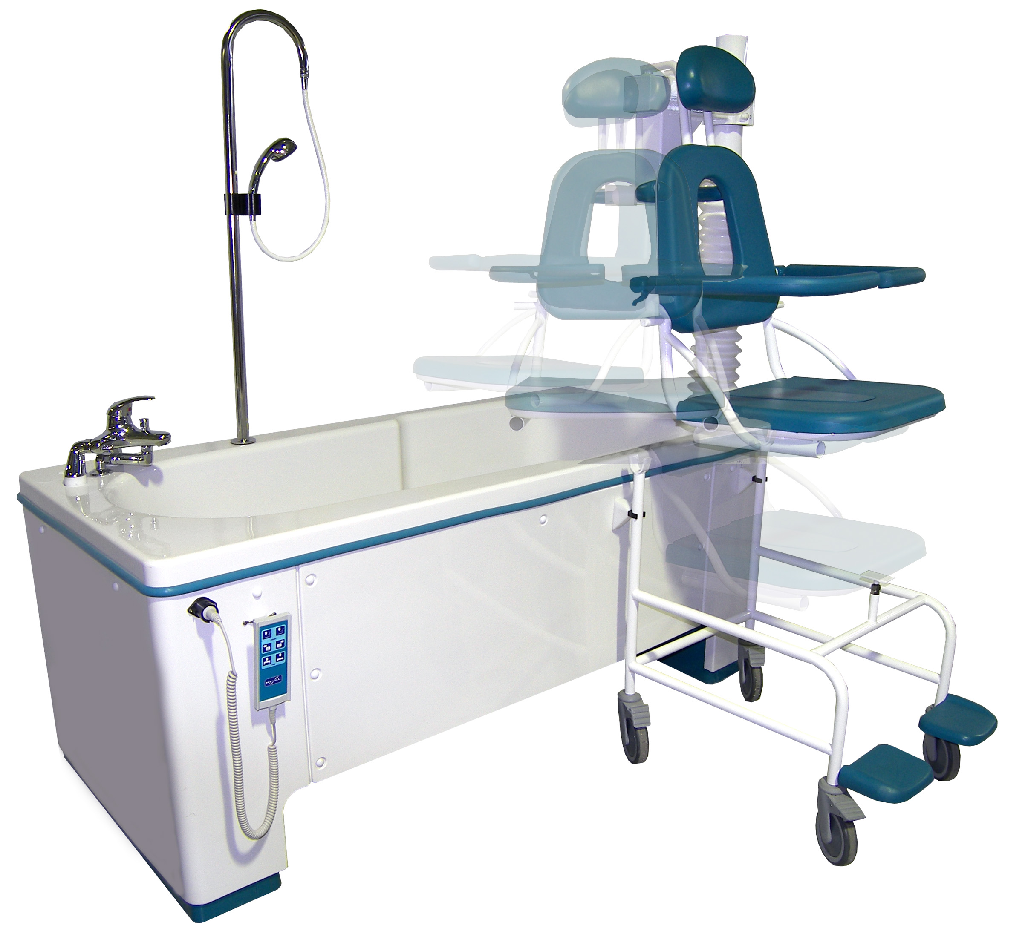


Z.A. Fief des Prises
Usseau 17220 Sainte Soulle
Tel: (33) 05.46.42.04.16
Fax: (33) 05.46.43.06.38

It is essential to read these directions for use before using your bathtub.
- SUMMARY -

CONTENTS PAGES

DIMENSIONS 2
- - - - - - - - - - - - - - - - - - - - - - - - - - - - - - - - - - - - - - - - - - - - - - - - - - - - - - - - - - - - - - - - - - - - - - - -

DESCRIPTION / HAND CONTROL 3
- - - - - - - - - - - - - - - - - - - - - - - - - - - - - - - - - - - - - - - - - - - - - - - - - - - - - - - - - - - - - - - - - - - - - - - -

TECHNICAL SPECIFICATIONS 4
- - - - - - - - - - - - - - - - - - - - - - - - - - - - - - - - - - - - - - - - - - - - - - - - - - - - - - - - - - - - - - - - - - - - - - - -

OPERATION / SECURITY 5
- - - - - - - - - - - - - - - - - - - - - - - - - - - - - - - - - - - - - - - - - - - - - - - - - - - - - - - - - - - - - - - - - - - - - - - -

SAFETY INSTRUCTIONS AND WARNINGS 6
- - - - - - - - - - - - - - - - - - - - - - - - - - - - - - - - - - - - - - - - - - - - - - - - - - - - - - - - - - - - - - - - - - - - - - - -

DIRECTIONS FOR USE

TRANSFER 7
POSITIONING OF THE TRANSFER SEAT 7
HANGING OF THE SEAY ON THE ARM 7
SEAT HEIGHTADJUSTMENT 8
SEAT LOWER ADJUSTMENT 8
BATH HEIGHT ADJUSTMENT 8 CLOSING/OPENING THE DRAINING PLUG 9
AIR WHIRLPOOL (OPTION) 9
- - - - - - - - - - - - - - - - - - - - - - - - - - - - - - - - - - - - - - - - - - - - - - - - - - - - - - - - - - - - - - - - - - - - - - - -

MAINTENANCE

CLEANING THE TUB 10 DISINFECTING THE TUB 10
CLEANING THE HYDROTHERAPY DEFFUSERS 11
- - - - - - - - - - - - - - - - - - - - - - - - - - - - - - - - - - - - - - - - - - - - - - - - - - - - - - - - - - - - - - - - - - - - - - - -

PERIODIC INSPECTION 12

- - - - - - - - - - - - - - - - - - - - - - - - - - - - - - - - - - - - - - - - - - - - - - - - - - - - - - - - - - - - - - - - - - - - - - - -

MAINTENANCE FORM (LOGBOOK) 13
- - - - - - - - - - - - - - - - - - - - - - - - - - - - - - - - - - - - - - - - - - - - - - - - - - - - - - - - - - - - - - - - - - - - - - - -

Page 1/13
DIMENSIONS :

Page 2/13
DESCRIPTION :

Head rest

Cleaning shower head

Bath/shower mixer

Hand control
Safety armrests

Trolley

Draining plug control / overflow
Seat

HAND CONTROL :

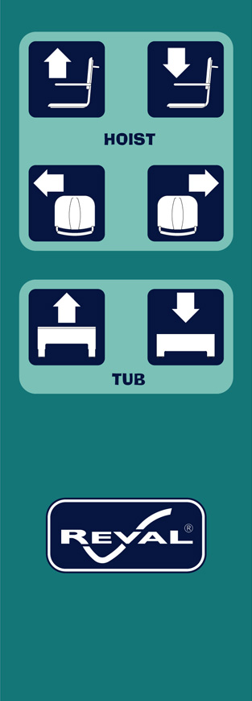

Seat Transfer Inward
Seat transfer Outward

Left Rotation
Right Rotation

Tub Lower adjustment

Tub Height Adjustment

Page 3/13

TECHNICAL SPECIFICATIONS :

BATHTUB:

Reinforced fiberglass tub, white colour.
Variable height via x2 - 24V electric actuators
Thermostatic water mixer Rada Autotherm 3 TMV3 Approved
IP66 6 functions hand control
Fresh water patient shower up-satand

PATIENT HOIST:

• Steel frame, Epoxy painting
• Seat and backrest in polyurethane.
• Removable head rest / adjustable height:
• Tubular steel, epoxy painting.
• X 4 Ø125mm brake-castors.
• Fold-up foot-rests.

PERFORMS:

• Max water volume: 240 litres (overflow limit)
• Tub lifting range: 300mm
• Hoist lifting range: 320mm
• Fill time @ 3 BAR: 3 min

ELECTRICITY:

• Electric feeding 230V - 50hz - 180W

Models:

CLARA Bath Fixed Height R/H P/c CLAR/RH/F
CLARA Bath Fixed Height L/H P/c CLAR/LH/F
CLARA Bath Variable Height Standard R/H P/c CLAR/STN/RH
CLARA Bath Variable Height Standard L/H P/c CLAR/STN/LH
CLARA Bath Variable Height Hydro-therapy R/H P/c CLARHYD/RH
CLARA Bath Variable Height Hydro-therapy L/H P/c CLARHYD/LH

CONFORMITY:

• 73/23/CEE
• 89/336/CEE
• NF EN 60335-1
• NF EN 60335-2-60
• NF C 15-100
• NF EN 1717

Page 4/13
Operating Function :

High/low functions are powered via 2 synchronised 24Vdc electric actuators.

Hoist raise/lower is controlled via a single 24Vdc electric actuator.

Hoist rotate is controlled by a single 24Vdc electric actuator.

Hand control has 6 functions, which control variable height tub adjustment, seat rotation, and seat rise and lower.

Bath and shower operation/temperature is controlled via the selector lever and temperature control knob situated on top of the TMV 3 thermostatic mixer. (See the thermostatic mixer manual provided for specific operating and servicing requirements).

The fresh water patient shower system mounted on a side of bathtub is also thermostatically controlled for safety and compliance with TMV 3 scheme criteria.

Hydro-therapy is provided by a dedicated closed system which pumps air through a pipe work system (via an electric air pump 230-240 Vac) into the bath tub which is defused and controlled by the three button control pad located at the foot end of the bath. (See section on Hydrotherapy on page 9)

SAFETY :

Seat rotation is only possible if tub is in low position and seat in high position!

The bath tub can only be raised if the seat is positioned over the bath tub!

Page 5/13

SAFETY INSTRUCTIONS AND WARNINGS:

Do not attempt to use this bathing system without first reading this manual.
To ensure safe operation, carefully read this entire manual, especially the section on "Safety Instructions and Warnings", before installing, operating, or servicing this equipment.

If anything is not completely understood, please contact Reval for more details.
Failure to comply with warnings in this manual may result in injury or damage to the appliance.
Keep this manual with the appliance and refer to it when required. Contents of this manual are subjected to change without prior notice to users. Updates can be sought from Reval or your local stockist.

- The clara bathing system must be installed by a certified installation technician.
- Clara systems must be fixes to the ground using the floor fixing provided.
- DO NOT immerse the hand control in water.
- DO NOT try to lift the tub.
- DO NOT stay underneath the tub during lowering.
- DO NOT fill over the maximum water level line.
- DO NOT pull excessively on the shower head.
- DO NOT place any object underneath the tub at any time.
- DO NOT use any electrical appliances near the tub.
- DO NOT use excessive force when operating the controls or taps.
- ALWAYS perform a daily check before using the bathing system.
- Each client should be assessed for his or her ambulatory capability to ensure the clients safety when
entering/ exiting the bathing system.
- ALWAYS be prepared before transferring a patient into the tub.
- ALWAYS check the water temperature before the patient enters the tub or before using the
Shower system.
- ALWAYS check the seat location pins are engaged before hoisting the patient.
- Clean bathtub after each use.
- Disinfect bathtub between each use.

Page 6/13
DIRECTIONS FOR USE:

__________________________________________________________________________

WARNING : This symbol is intended to alert the user to hazards or unsafe practices which

could result in serious bodily harm.

CAUTION: This symbol is intended to alert the user of the presence of important operating
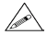
and maintenance instructions which could prevent product damage or possible personal injury.

NOTE : This symbol offers helpful information concerning certain operating procedures.
__________________________________________________________________________

1) TRANSFER OF THE PATIENT

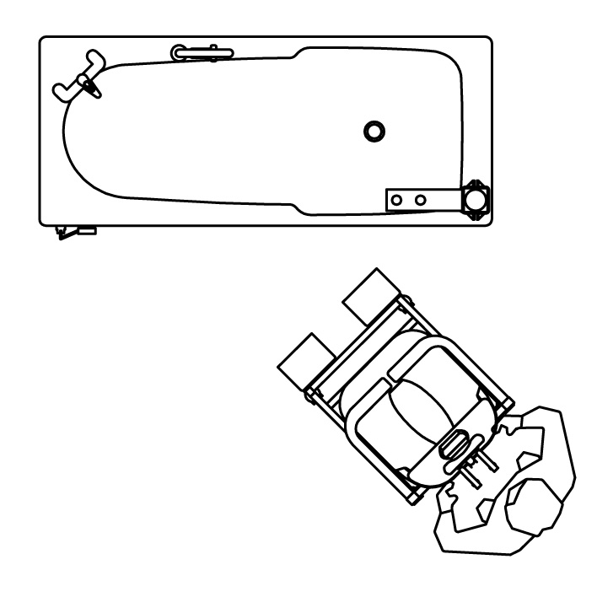
Before transfer, check the safety armrests are in the down position and th then approach the bath.

2) POSITIONING THE SEAT

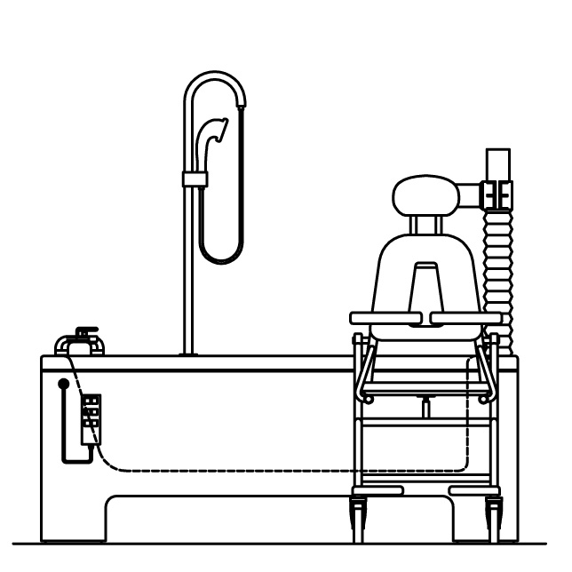
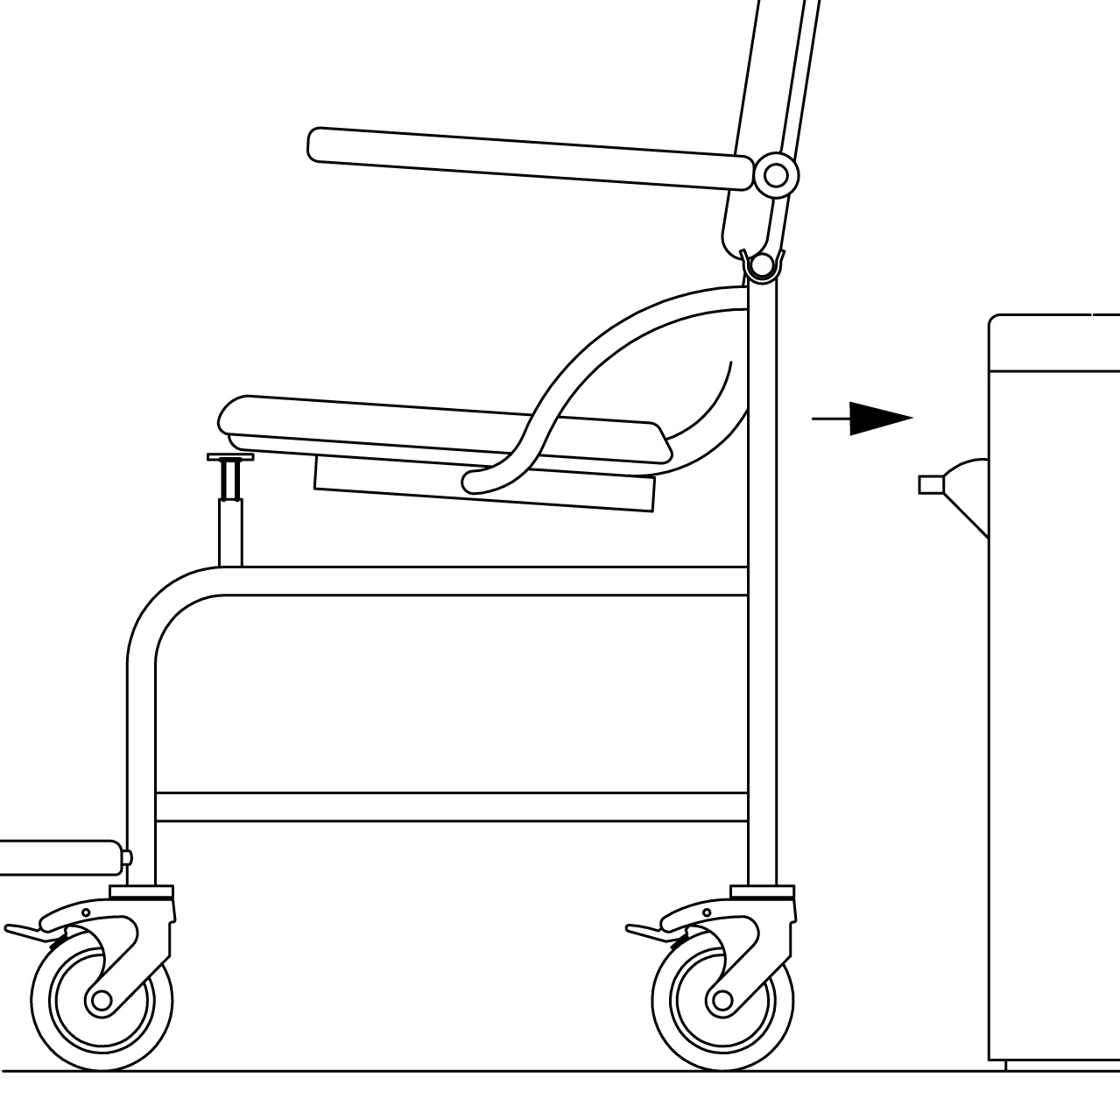
Ensure the transfer seat is correctly
Located into the two docking clips as
Shown in diagram 2 positioning seat

3) ATTACHING THE SEAT TO THE HOIST

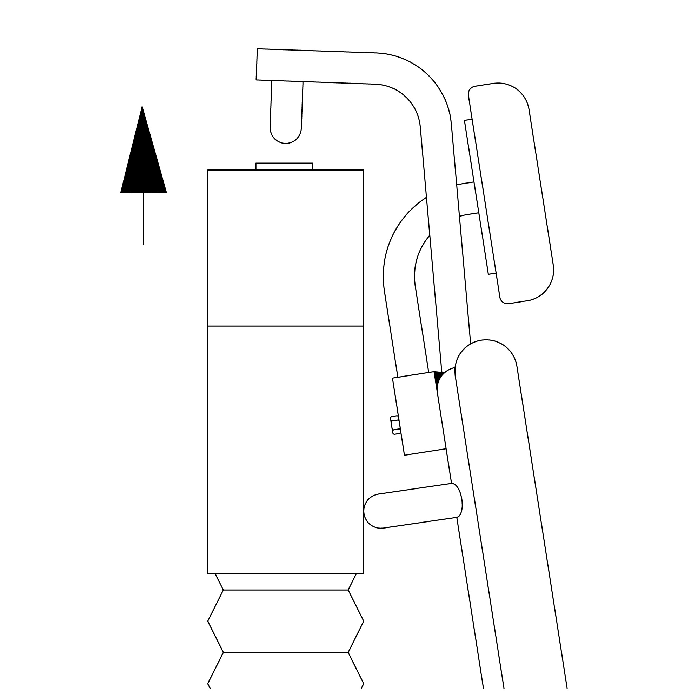
Ensure the seat location pins are correctly positioned before hoisting begins.
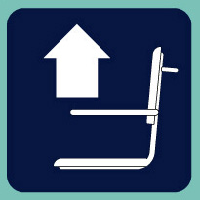
To rise the seat and patient depress seat raise button.

Take care to this operation.

Page 7/13
DIRETIONS FOR USE AND MAINTENANCE:

4) SEAT RISEING

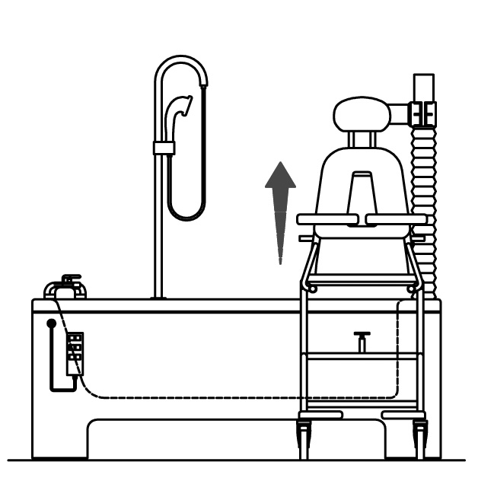
.

Depress the seat rise button to
Lift patient. Then remove the trolley.

5) SEAT ROTATION AND PATIENT TRANSFER OVER BATH

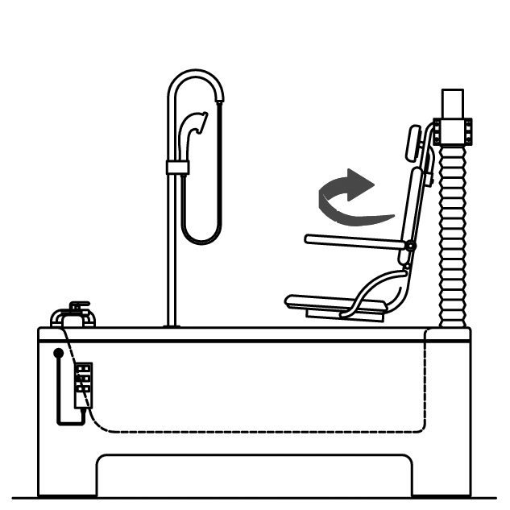
Depress the transfer in button to
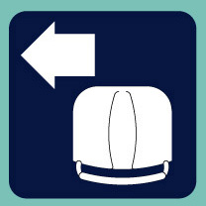
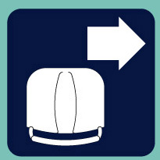
Transfer the patient over the bath.
Or to the outward transfer position.

6) BATH VARIABLE HEIGHT ADJUSTMENT

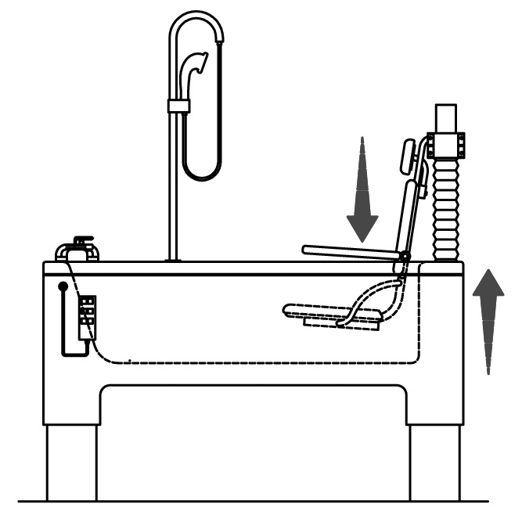

Depress the bath rise button to raise
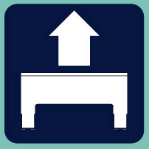
he tub to the desired high.

Depress the seat lower button to
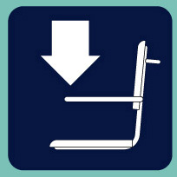
Lower the patient to the preferred
Depth.

Page 8/13
DIRECTION FOR USE AND MAINTENANCE:

OPENING/CLOSING THE DRAIN PLUG

Turn the button in a clockwise direction to close the drain plug and counter clockwise to open it

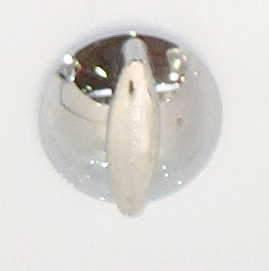

OPENING CLOSING

AIR – Hydro-massage

Air is pumped via an independent system to several outlet diffusers which located strategically in to rows at the bottom of the bath tub. The diffusers are positioned so that that deliver therapy the major muscle groups on the patient’s body and the therapy intensity can be adjusted, via the buttons in the diagram below.

Page 9/13

MAINTENANCE:

CLEANING THE TUB

Only use liquid based products e.g.(liquid soap).

Don't use abrasive products like "scouring cream" to avoid scratches on the tub surface "Gelcoat".

DISINFECTION OF THE TUB

- Spray a suitable cleaner or disinfectant onto the interior tub surface.
- Let the disinfectant act on the surface of the bath for the manufacturers recommended period.
- Thoroughly rinse the interior tub surfaces with fresh water.
- Dry the interior tub surfaces with a clean soft cloth.
- Alcohol wipes and after market solutions can be used. If in doubt, contact Reval to ensure compatibility of the proposed materials to be used on the appliance.

Page 10/13

CLEANING THE AIR-HYDROTHERAPY DEFUSERS

- Diffusers: Should be cleaned on a regular basis dependent on usage.

-Function: Air is blown through the chromed diffusers. Debris
can build up below the diffusers and impair the function and effectiveness.

To clean the diffusers follow stages 1-4:

Stage 1 :
Switch off the hydro-therapy function then totally empty the bath.
Stage 2 :
Use a flat screwdriver to remove the diffuser cap.

Stage 3 :
Clean the chromed chrome diffuser cap and the jet orifice.

Stage 4 :
Reposition the diffuser cap on its mounting.
Then with a soft mallet, tap the chromed air jet cap (diffuser) . Check that it is correctly positioned on the nozzle mounting. Switch on the bath and check that air is flowing freely around the circumference or the diffuser.

Page 11/13

PERIODIC INSPECTION:

1) Periodic inspection of the bathtub should be undertaken at the time intervals stated by the manufacturer, but at least once a year. By periodic inspection is meant a visual examination on all the functions of the bathtub and particularly on the safety systems
Every inspection should include a working load of one (1) lifting cycle with the maximum load.

2) Periodic inspection should be performed by a person who is suitably and properly qualified and well acquainted with the design, use and care of the bathtub. The scope of the periodic inspection should be included in the manual supplied with the bathtub.

3) Any observations of importance for the safety of the bathtub should be noted, preferably in a logbook which should be retained by the person (s) responsible for the servicing / maintenance of the bathtub.

The date when corrective actions are taken, in response to noted observations, should also be noted in the logbook.

4) A record of the date of inspection of the bathtub and inspection result should be noted in the logbook together with the signature of the inspector.

5) If periodic inspection reveals any defect, wear or other damage that jeopardises the safety of the bathtub, the owner should immediately be notified.
In the event of immediate danger to safety, the bathtub should immediately be taken out of service. It may then not be used until the deficiency has been eliminated.

6) Defects and damages of importance to the safety of the bathtub that have occurred between inspections and have already lead to corrective actions should be entered in the logbook.

7) Defects and damages should be reported back to Reval for action.
This feedback should be reported in the logbook.

Page 12/13

MAINTENANCE FORM (LOGBOOK):

Agent
(name and signature)
Corrections
Observations
Safety parts

Control date

Page 13/13

